DATA STRUCTURES

LAB 1

TASKS:
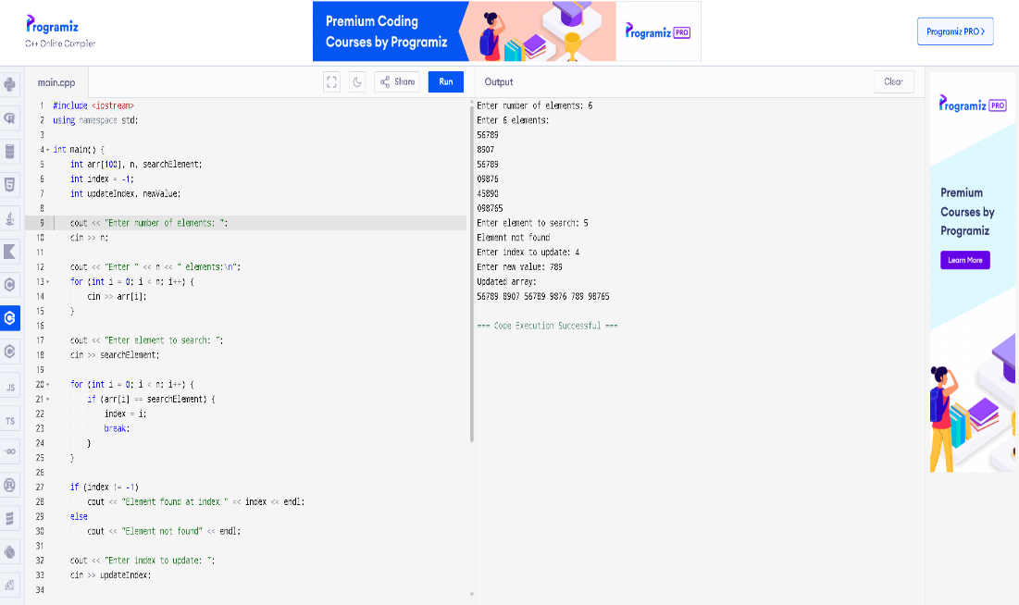
Write a program to search an element in a 1D array using linear search and display its index. Update the value at a given index in a 1D array.

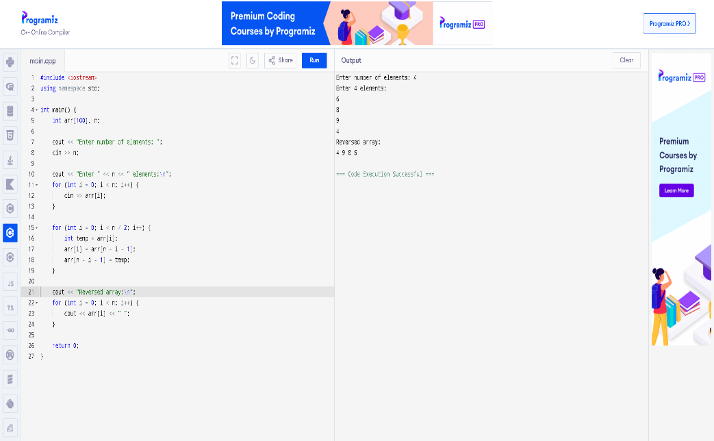
Write a program to reverse a 1D array.

